The Chambers held its 13 years Anniversary Annual Dinner on December 07, 2019, Saturday at 7:00 PM. At Grand Zizzi Hall (Level-2), Platinum Grand, 52, Road-11, Block-F, Banani, Dhaka-1213. Dr. M. Fouzul Kabir Khan, Ex Secretary, Power Division & Founder CEO, IDCOL was the guest of honour in the event and delivered Speech on “Power, Energy & Infrastructure projects of Bangladesh.” By Dr. M. Fouzul Kabir Khan

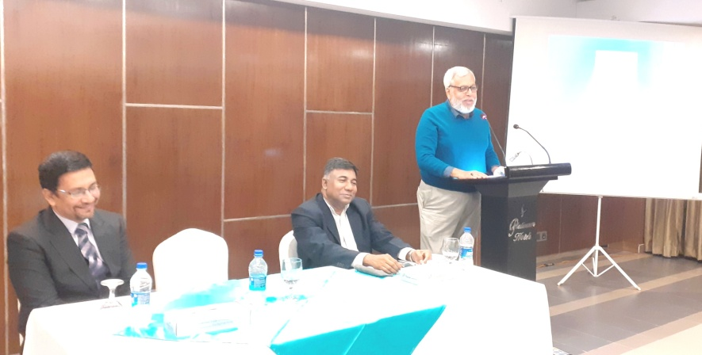  Dr. M. Fouzul Kabir Khan, Ex Secretary, Power Division & Founder CEO, IDCOL was the guest of honour in the event and delivered Speech on “Power, Energy & Infrastructure projects of Bangladesh.” | 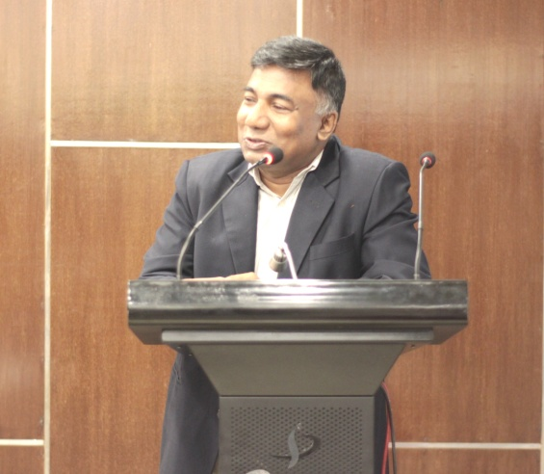  Engr. Mohammad Hossain, Director General of Power Cell was the special guest and delivered Speech on “Growth of Power Sector of Bangladesh”.

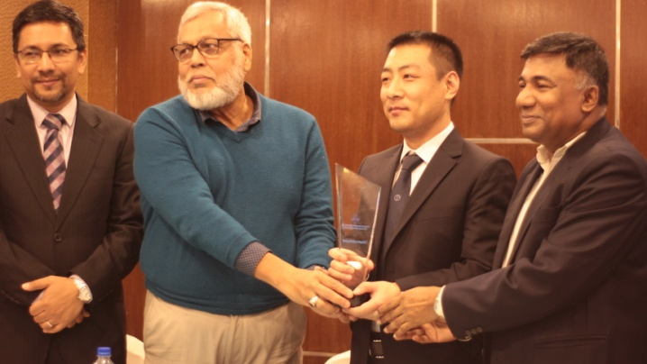  Mr. Hu Jingyu to receive the crest from Rahman’s Chambers handed over by Dr. M. Fouzul Kabir Khan on behalf of CCCC First Harbor Engineering Co., Ltd. (Mariland Engineering Company Ltd.) from our Investment department and Opening Subsidiary in Bangladesh. | 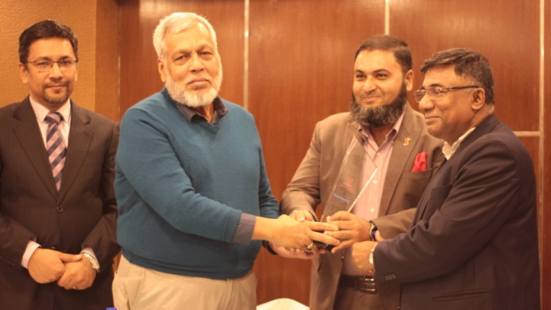  Mr. Abdur Rahman to receive the crest from Rahman’s Chambers handed over by Dr. M. Fouzul Kabir Khan on behalf of Unitex Group  From our Corporate Department and Excellent Entrepreneurship.
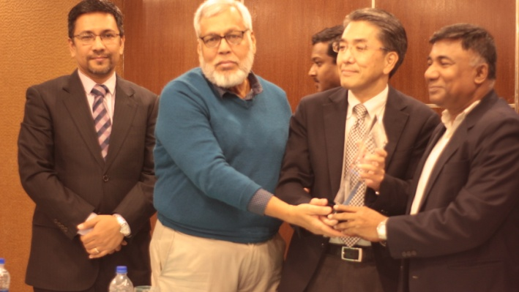  Mr. Sagawa Koji to receive the crest from Rahman’s Chambers handed over by Dr. M. Fouzul Kabir Khan on behalf of Maruhisa Pacific Co., Ltd. From our Dispute Resolution department and Contribution to Alternative Dispute Resolution. | 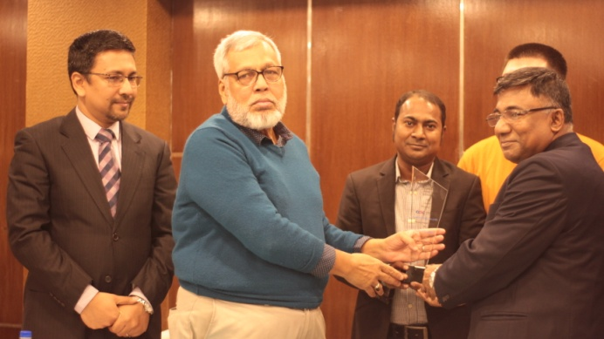  Mr. Md. Safaet Hossain to receive the crest from Rahman’s Chambers handed over by Dr. M. Fouzul Kabir Khan on behalf of Northeast No. 1 Electric Power Construction Co., Ltd. (NEPC) From our Construction Department and Excellence in EPC completion.
The following participant amongst others attended in the Annual Dinner Mr. Zia U Ahmed, Chairman, Venture Investment Partners Bangladesh Ltd. (VIPB); Capt. Giasuddin Chowdhury, Managing Director , Orient Overseas Container Line (OOCL); Mr. Liu Shuang Chung Managing Director, How Are You Textile Limited; Mr. Md. Masudur Rahman (Masud), Asst. General Manager, How Are You Textile Limited; Mr. Dilip Kumar Paul, A.G.M (Comm.), Hwa Well Textiles (BD) Limited ; Mr. Saqib Ahmed Siddiqui, Group Coordinator, Business Development, Unitex LP Gas Ltd., Mr. Khandakar Mostaque Mahmud ; Managing Director ; Quality Timber Industries Ltd., Mr. Jahirul Islam , AGM (Production) , Maruhisa Pacific Co., Ltd.; Mr. Md. Ataur Rahman, Head of General Service , The UAE- Bangladesh Investment Company Limited (UBICO); Mr. Md. Anis Akbar , Executive Director , Armada Spinning Mills Limited ; Mr. Md. Nasir Ul Alam Sumon ; General Manager, Sales , Siam City Cement (Bangladesh) Limited; Mr. Mohammad Saifullah, Government Relations & Operations Specialist , VSO Bangladesh; Ms. Miftahul Jannat, Executive, Finance & Accounts, Grameen Danone Foods Ltd; Mr. Chetan Kanojia, Territory Manager , Shakti Pumps Bangladesh Limited ; Prof. (Dr.) Md. Shah Alam, Director, Impulse Hospital; Mr. Yang Wenchuang, Representative in Bangladesh, Dong Fang Electric International Corporation; Mr. Pingkal Saha , Deputy General Manager, Orient Overseas Container Line (OOCL); Colonel (Prof.); Mr. Mohd. Shoyeb Ali, Ex Senior Vice President and Head of Investment Dept., First Security Islami Bank Ltd; Mr. Yang Yanjie, Deputy Project Manager, TBEA CO., LTD; Mr. Hu Jingyu, Deputy General Manager, CCCC First Harbor Engineering Co., Ltd.; Mr. Renbin Lyu, Marketing Director, CCCC First Harbor Engineering Co., Ltd.; Mr. Muhammad A. (Rumee) Ali, Chief Executive Officer, Bangladesh International Arbitration Centre (BIAC); Mr. M A Akmall Hossain Azad, Director, Bangladesh International Arbitration Centre (BIAC); Ms. Mahbuba Rahman Runa, General Manager , Bangladesh International Arbitration Centre ; Mr. Muhammad Azizur Rahman, Retd. Commodore, Bangladesh Navy; Mr. A. A. M Zakaria, Director, Bangladesh Commerce Bank Ltd.;

